
OOP PROJECT
Injury Assist system

SUPERVISED BY :
DR.Hend Saad
ENG.Maiada Mahmoud

Presented by:
Retaj Ali (231005689)
Rawan Amr (231006573)
Youssef Hany (231014237)
Mohamed Salah (231006628)
Shehab Elden Wael (231006398)

SDJs: Good health and well being.

introduction to the injury assist system:

injury assist system’s role is providing essential and fast support during critical unexpected injuries, minimizing the risks associated with delayed care ensuring that injuries are properly assessed and given a topical treatment preventing them from worsening.

Our motivation:
- To help categorize the injuries and easier the process of diagnosis to the doctors.

- Make a helpful report to all patients that can help them in their future life.

Functions of injury assist:
- Determine the injury type and its severity level .
- Assist the injury type with a suitable treatment.
- Booking system for booking appointments.
- Save the patient data and make a summarized report for each patient.

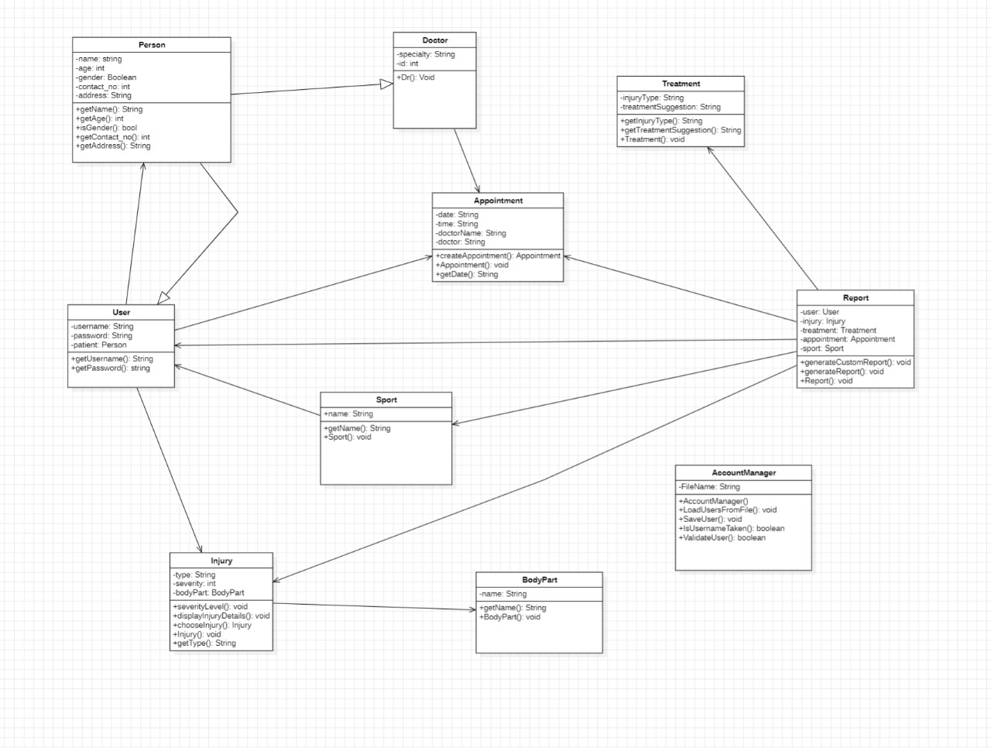
UML
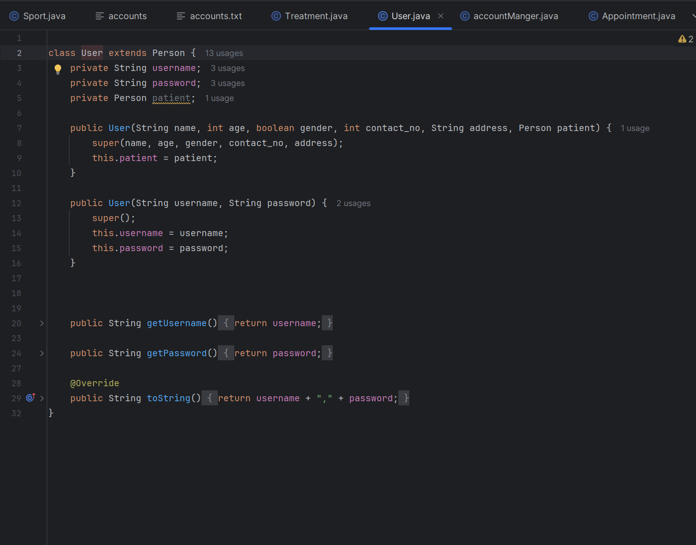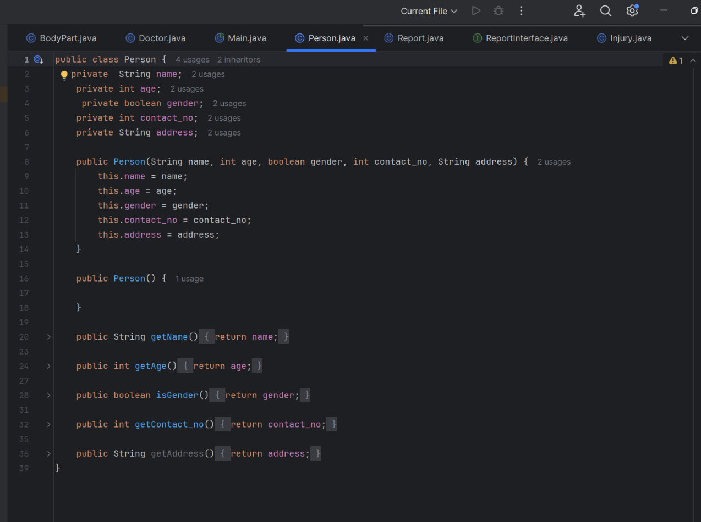
WE USED THE INHERITANCE IN LINKING THE PERSON CLASS WITH THE USER
WE USED THE ENCAPSULATION IN HIDING THE INTERNAL DATA OF ALL OF OUR ATTRIBUTES.

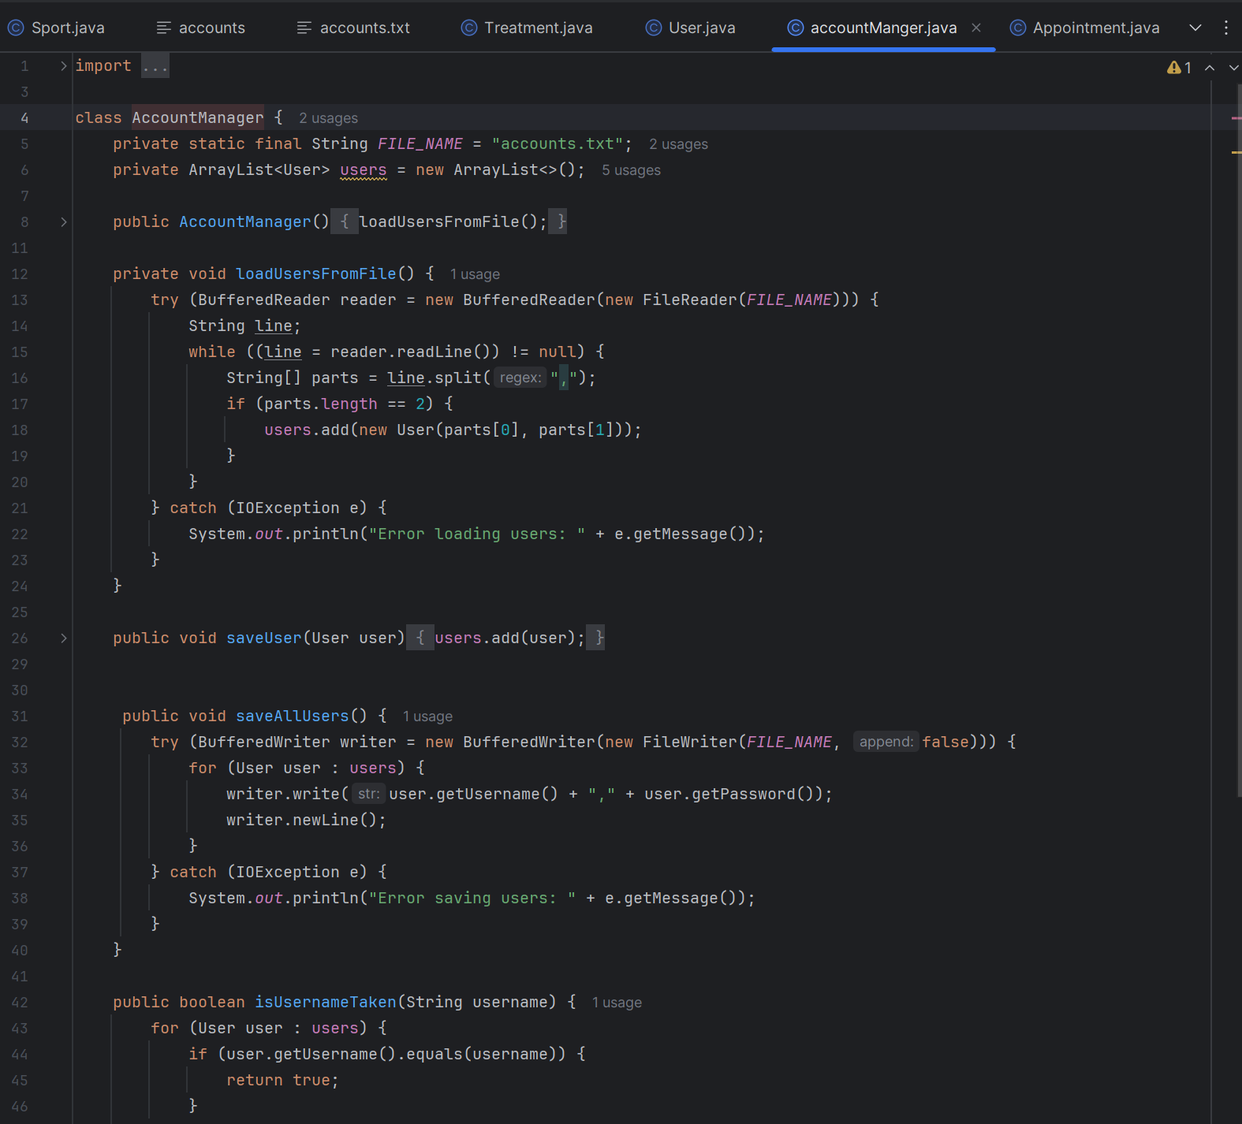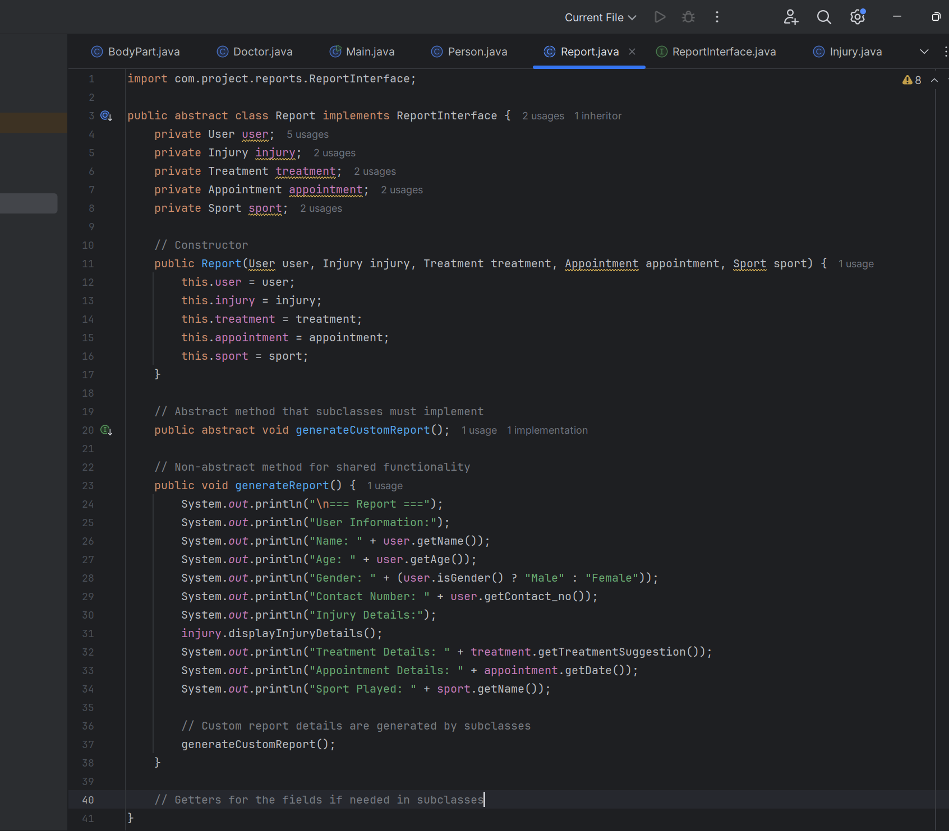
We used the files and exceptions to control the login form & signup form as the data of the users are saved in the file and the exception ensure that the account is correct
We did an abstract method to generate customer report.
An abstract class in Java is a class you can't create objects from. It can have methods with or without a body and is meant to be extended by other classes.

Validation is the process of checking if input or data meets specific rules, requirements, or standards before being processed or used.

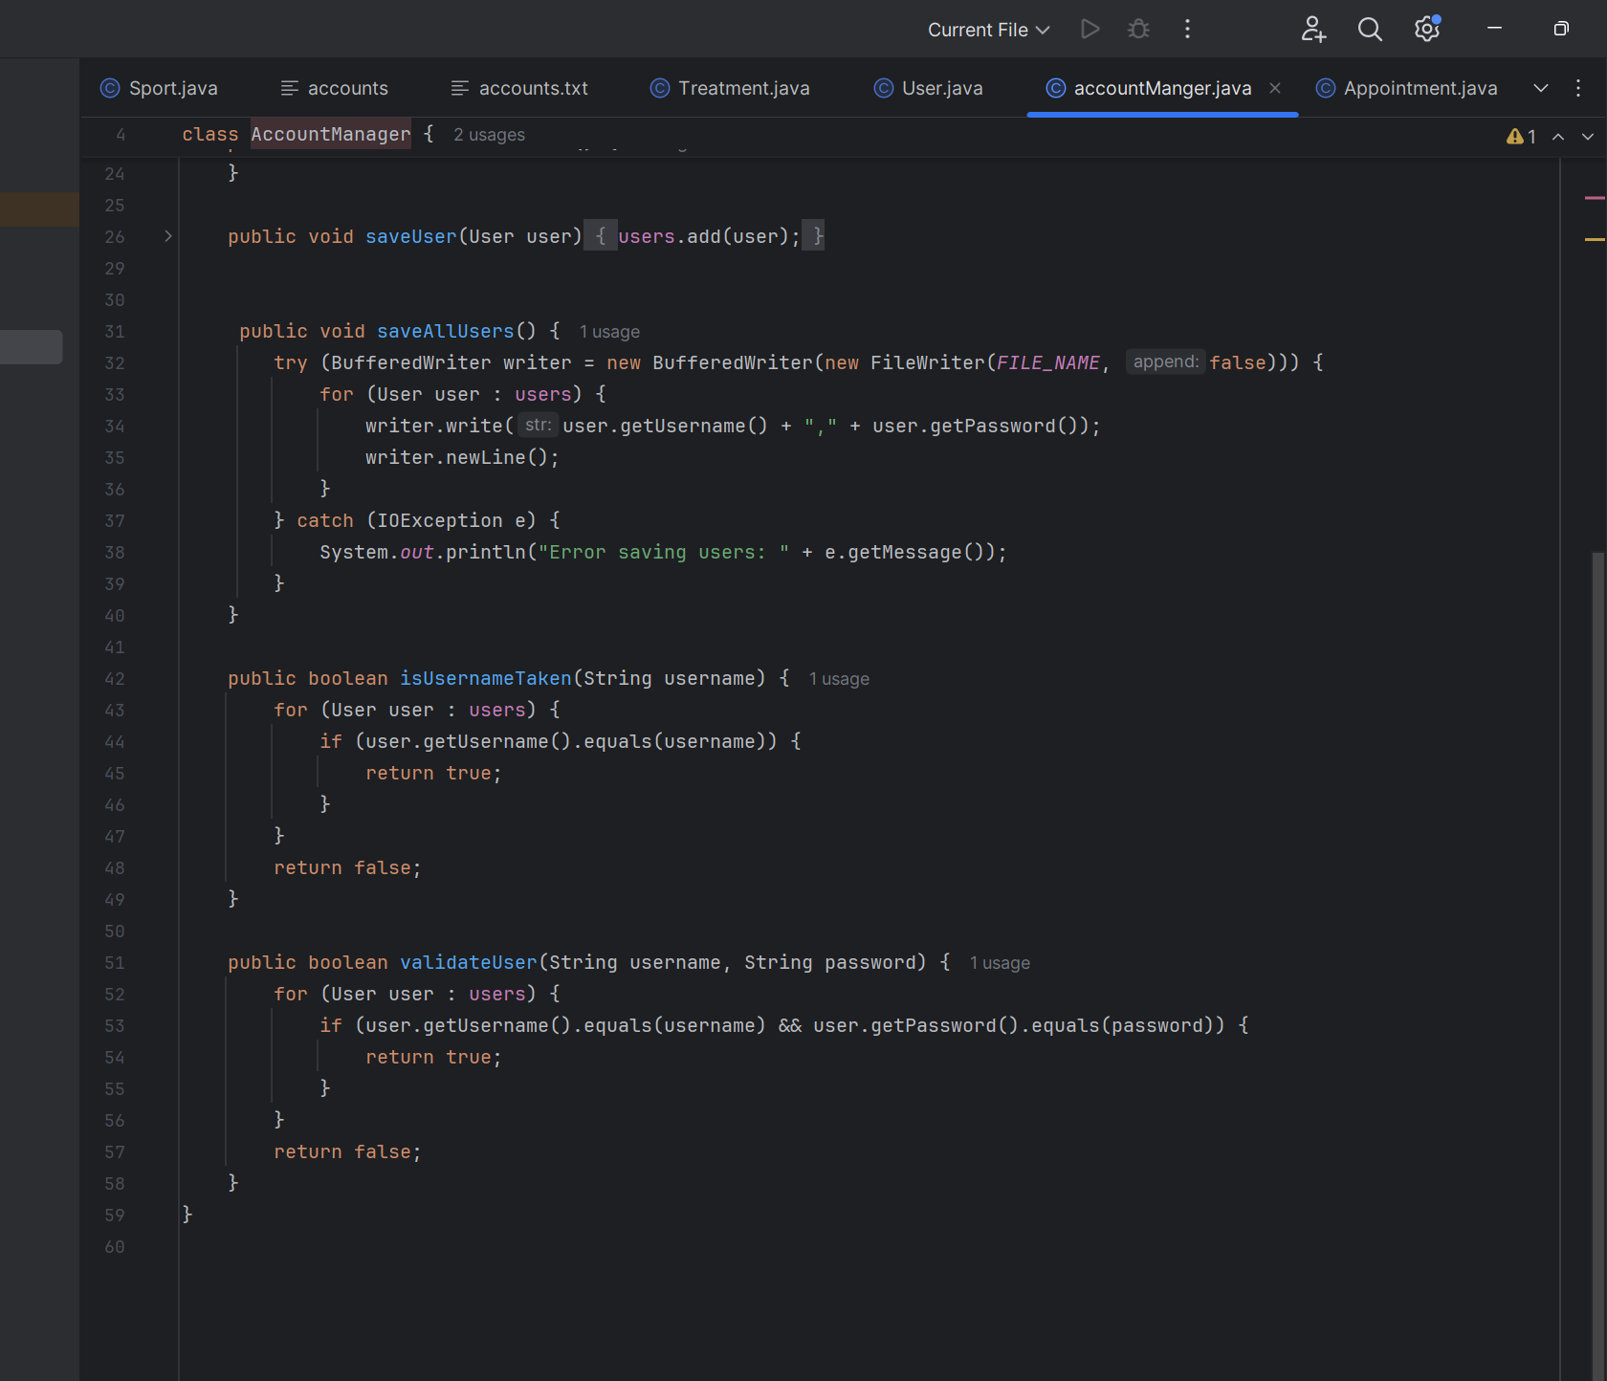
Used the validation to make sure that the logged in user name and password the correct

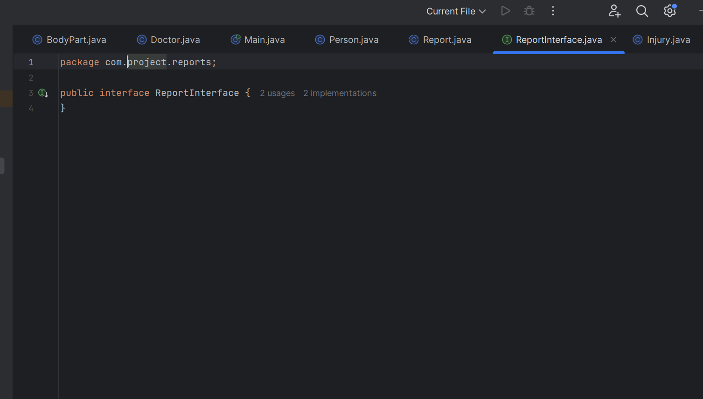
interface is a blueprint of a class that defines a set of methods that a class must implement. It is used to achieve abstraction and multiple inheritance, containing only method signatures

We then used the composition most in the report class



The output
